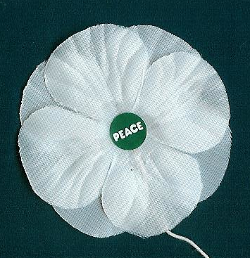 | BC Elementary & Secondary Schools  White Peace Poppies  Teacher's Order Form - 2017

School Name _____________________________________________  Address: ______________________________________________  ______________________________________________  Contact Name & email: _____________________________________  Grades or Ages participating: _______________________________ | 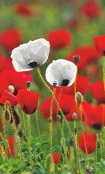

Vancouver Peace Poppies has partnered with local teachers to make white peace poppies more available and affordable for BC schools. Generous supporters and a 2014 Ed May Social Justice Grant from the BCTF allowed us to purchase the traditional white cloth poppies from the British Peace Pledge Union and make them available to schools at a significant discount. Supplies at the subsidized price may be limited; please order ASAP to ensure your school's order can be filled.
With each poppy we include a small safety pin, a colourful 'business card' leaflet giving some reasons for wearing a white poppy and a short history of the campaign. Each school will also receive a beautiful colour poster of red and white poppies with the text "White Poppies for a Culture of Peace". Pins are supplied loose, but instructions for attaching them are provided.
We distribute white poppies as a consiousness raiser, not a fundraiser. Proceeds of our campaign cover part of our costs and support the education work of the Peace Pledge Union in Britain which makes the poppies.
Mail a cheque payable to T. Gagné to 8016 Jadetree Court,Vancouver, BC
V5S 4A8, or email info@PeacePoppies.ca for Interac eTransfer instructions.
To save time, you can email us the information requested on this form.

I would like to order the following :
Item | Cost | Quantity | Total $
White Cloth Poppies  for a BC Elementary School | @ $ 0.35
White Cloth Poppies  for a BC Secondary School | @ $ 0.60
For Student-run campaigns see peacepoppies.ca/peacepoppies-schools.html
Web: PeacePoppies.ca Email: <info@PeacePoppies.ca> Tel: 604-437-4453

