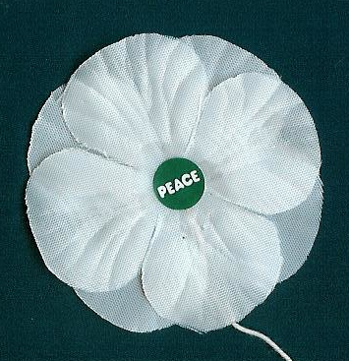 | Canadian Schools  White Peace Poppies  Teacher's Order Form - 2018

School Name: _____________________________________________  Address: ______________________________________________  ______________________________________________  Contact Name & email: _____________________________________  Grades or Ages participating: _______________________________ | 

We want to make white peace poppies more available and affordable for schools across Canada. Donations from generous supporters allow us to purchase the traditional white cloth poppies from the British Peace Pledge Union and make them available to school teachers for a subsidized price – a suggested donation of only $.60/poppy.
This price applies to poppies purchased by teachers or schools for classroom use in elementary or secondary schools. For help with student run campaigns see our "Student Campaign Form" at peacepoppies.ca/peacepoppies-schools.html . Supplies at the subsidized price may be limited; please pre-order ASAP to ensure your school's order can be filled.
With each poppy we include a small safety pin, and for grades 3 and up a colourful info. card giving some reasons for wearing a white poppy and a short history of the campaign. Each school will also receive a beautiful colour poster of red and white poppies with the text "White Poppies for a Culture of Peace".. Pins are supplied loose, but instructions for attaching them are provided.
Poppies are quite durable and can be collected for reuse after the Remembrance Day assembly.
We distribute white poppies as a consciousness raiser, not a fundraiser. Proceeds of our campaign cover part of our costs and support the education work of the Peace Pledge Union in Britain which makes the poppies.
Mail a cheque payable to T. Gagné to 8016 Jadetree Court, Vancouver, BC
V5S 4A8, or email info@peacepoppies.ca for Interac eTransfer instructions.
To save time, you can email us the information requested on this form.

I would like to order the following:
Item | Cost | Quantity | Total $
White Cloth Poppies | @ $ 0.60

Web: PeacePoppies.ca Email: <info@PeacePoppies.ca> Tel: 604-437-4453

