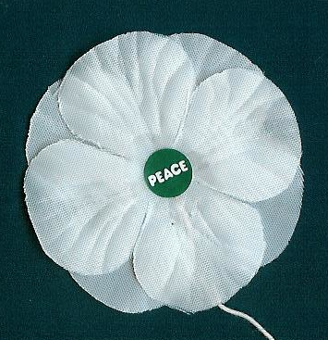 | Student Campaign Order Form - 2018  White Peace Poppy Materials

School Name _____________________________________________________  Address: _____________________________________________________  _____________________________________________________  Contact Name & email: _____________________________________________  Classes or Clubs participating: _____________________________________ | 
Running their own White Poppy Campaign is a great way for high school students to promote peace in their school community. Campaigns can be sponsored by a Social Justice class or classes, a school club, or simply a group of friends. Since student groups can expect to recover their poppy costs through donations Vancouver Peace Poppies doesn't provide subsidized cloth poppies. We can sometimes provide limited numbers of cloth poppies at cost, but we prefer that student groups order them directly from Britain. Alternately, groups could print and cutout their own homemade white poppies.
To get you started with the basics we can provide:
- Advice on ordering white cloth poppies directly from Britain
- Templates for printing attractive white poppies on photo paper
If you direct order or print your poppies we will provide at no charge:
- Pins & suggestions for attaching them to your poppies
- Colourful informative 'business card' leaflets giving some reasons for wearing a white poppy and a short history of the campaign
- A beautiful colour poster with the text "White Poppies for a Culture of Peace"
At Vancouver Peace Poppies we run our White Poppy Campaign as a consciousness raiser, not a fundraiser. The suggested donations below cover our costs and help support the education work of the Peace Pledge Union in Britain, which makes the poppies. Providing subsidized or free materials to schools is made possible by the financial support of a few generous donors.
Mail this form to T. Gagné to 8016 Jadetree Court, Vancouver, BC, V5S 4A8
or email the information requested above to info@PeacePoppies.ca

We have directly ordered/printed _____ white poppies for our school campaign.
We would like to order the following supplies the following supplies:
Item | Cost | Quantity | Total $
Small safety pins, poster & card leaflets only | no charge
Pack of 25 White Cloth Poppies | @ $27.00
Pack of 50 White Cloth Poppies | @ $53.00 | (max 2 pks/order)

Web: PeacePoppies.ca Email: <info@PeacePoppies.ca> Tel: 604-437-4453

